|  |  |
| --- | --- |
| **Comprehensive Geriatric Assessment** | |
| **Assessment Date**: | **Accompanied By**: |
| **Primary Contact Person**: | **Phone Number**:  **Phone Number (alt)**: |
| **General Practitioner**: | **Consent:** |
| **Referral** | |
| **Referral Source**:  **Referral Date**: **Reason for Referral**: **AUA Score:** | |
| **Patient Expectations**:  **Caregiver Expectations**: | |
| **Social History** | |
| **Place of Birth**: | **First Language**:  **Other Languages Spoken**:  **Language spoken daily at home**: |
| **Education**: | **Handedness**: |
| **Past/Current Occupations**: | |
| **Marital Status and Duration**: | |
| **Living Arrangements (i.e. alone, spouse, institution)**:  **Type of Dwelling (i.e. house, apartment, single storey)**: | |
| **Children**:  **Number of Children**: **Local Supports**: **Contact with Patient**: | |
| **Power of Attorney**:  **Name**: | **Financial**:  **Personal Care**: |
| **Eligible Veteran (Overseas service for more than 1 year)**:  **Other Private Insurance Coverage**: | |
| **History of functional decline** | |
| **Describe the change in function (i.e. when and why did the change occur) and trajectory (i.e. steep, gradual, peaks**  **and valleys, gradual descending plateaus, etc.) of functional decline:**  **Risk factors for functional decline:**  Cognitive impairment Low level of social contacts Depression low level of physical activity High disease burden Polypharmacy | |

|  |  |  |
| --- | --- | --- |
| High or low BMI Poor self-perceived health  LE functional limitation Smoking  Visual impairment Other: | | |
| **Functional Status**  **(I=independent, AP=assistance due to physical limitation, AC=assistance due to cognitive limitation, DP=dependent due to physical limitation, DC=dependent due to cognitive limitation, N/A=never completed by client in the past)** | | |
| **Activities of Daily Living** | | |
|  | **Current Status** | **Previous Status** |
| **Transferring** |  |  |
| **Toileting** |  |  |
| **Continence** |  |  |
| **Eating** |  |  |
| **Mobility** |  |  |
| **Bathing** |  |  |
| **Dressing** |  |  |
| **Grooming** |  |  |
| **Instrumental Activities of Daily Living** | | |
|  | **Current Status** | **Previous Status** |
| **Using phone** |  |  |
| **Grocery**  **Shopping** |  |  |
| **Meal**  **Preparation** |  |  |
| **Laundry** |  |  |
| **Housekeeping** |  |  |
| **Medication** |  |  |
| **Finances** |  |  |
| **Transportation** |  |  |
| **Formal and**  **Informal**  **Supports** |  |  |
| **Current**  **Hobbies** |  |  |
| **Exercise** |  |  |
| **Cognition** | | |
| *(i.e. ST vs. LT memory, word finding difficulties, disorientation, decreased ability to perform motor task or to multitask)* ***and history***  ***of onset*** *(i.e. gradual, abrupt)* ***and progression*** *(i.e. smooth, fluctuating, stepwise)* ***of cognitive impairment:*** | | |

|  |
| --- |
| **Current Symptoms**:  **Decreased short term memory**:  **Repetitiveness**:  **Word finding difficulty**:  **Decreased recognition of faces/people**: **Disoriented in new places/getting lost**: **Decreased ability to Multitask**:  **Decreased ability to perform motor tasks**: |
| **Summary of Cognitive Testing**:  **SMMSE**:  **Clock Drawing**:  **Semantic Fluency**: **Phonemic Fluency (FAS)**: **MoCA**:  **Trails A**:  **Trails B**: |
| **Mood** |
| **Past history of depression and any past treatment/institutionalizations**:  **Currently, do you often feel sad or depressed**?  **Details recent/current regarding onset, progression and symptoms**:  **Has the patient experienced paranoia, delusions, hallucinations, or agitation/aggression?** |
| **SIGECAPS** *(completed if mood concerns identified above)***:**  **Sleep**: **Interests**: **Guilt**: **Energy**:  **Concentration**:  **Appetite**:  **Psychomotor slowing/Agitation**:  **Suicide: Active**: **Passive**:  **Total Positive SIGECAPS:** |
| **Summary of Mood Screens** *(completed if total positive SIGECAPS yields ≥2)***:**  **GDS**: **Cornell**: **BDI:** |
| **Sleep** |
|  |

|  |  |  |
| --- | --- | --- |
| **Nutrition** | | |
| **Have you lost any weight within the last 6 months**? | | |
| **Pain** | | |
| ***Include history of onset, affected areas, PQRST, effect on activity, treatments/medications:*** | | |
| **Falls/Dizziness** | | |
| **Have you had any falls**?  **Patient Risk Factors**:  Polypharmacy Sedative use Uses mobility aid Weakness MSK conditions Vision impairment Hearing impairment Cognitive impairment Risk factors in home  environment  Nutritional concerns Postural hypotension Incontinence | | |
|  |  | Other: |
| **Continence** | | |
| **Bladder** | | |
| **Urinary Incontinence**:  **Urgency**: **Hematuria**: **Stress**: **Frequency**: **UTIs**: **Nocturia**: | | |
| **Bowel** | | |
| **Fecal Incontinence**:  **Constipation**:  **Diarrhea**:  **GI Bleed**:  **Bowel Routine**: | | |
| **Past Medical/Surgical History** | | |
| **Allergies: Hearing**: **Vision**:  **Seizures/head injuries**: | | |
| **Have you had any Emergency Department visits in the last year**?  **Have you had any hospitalizations in the last year**? | | |

|  |  |  |  |  |  |  |
| --- | --- | --- | --- | --- | --- | --- |
| **Smoking History**: | | | | | | |
| **Alcohol History**: | | | | | | |
| **Family History:**  **Parents**: **Siblings**: **Children**: | | | | | | |
| **Medication *\*include OTC meds/ herbs/ vitamins/ etc.*** | | | | | | |
| **Pharmacy**:  **How are medications taken (i.e. reminders, blister pack)**?  **Allergies to medications**: | | | | | | |
| **Medication** | **Dose/Frequency** | **Start Date** | **Stop Date** | **Ordered By** | **Pill Count** | **Comments** |
|  |  |  |  |  |  |  |
|  |  |  |  |  |  |  |
|  |  |  |  |  |  |  |
|  |  |  |  |  |  |  |
|  |  |  |  |  |  |  |
|  |  |  |  |  |  |  |
|  |  |  |  |  |  |  |
|  |  |  |  |  |  |  |
|  |  |  |  |  |  |  |
|  |  |  |  |  |  |  |
|  |  |  |  |  |  |  |
|  |  |  |  |  |  |  |
|  |  |  |  |  |  |  |
|  |  |  |  |  |  |  |
|  |  |  |  |  |  |  |
|  |  |  |  |  |  |  |
| **Clinical Frailty Score:** | | | | | | |
| **Recommendations** | | | | | | |
|  | | | | | | |

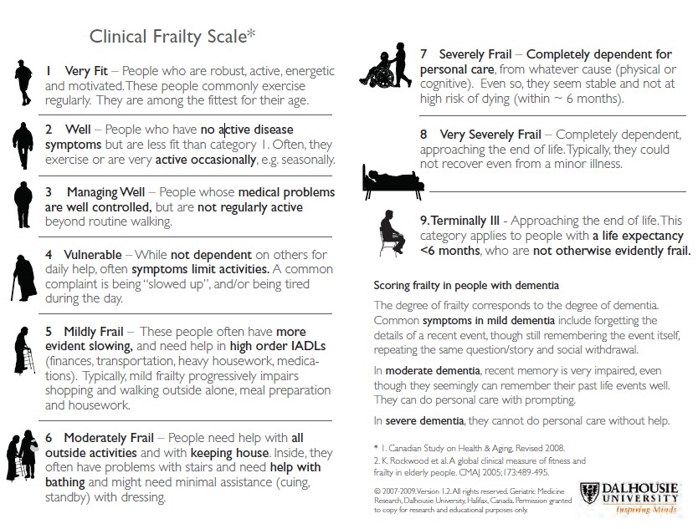

**Assessment Urgency Algorithm (AUA tool)**

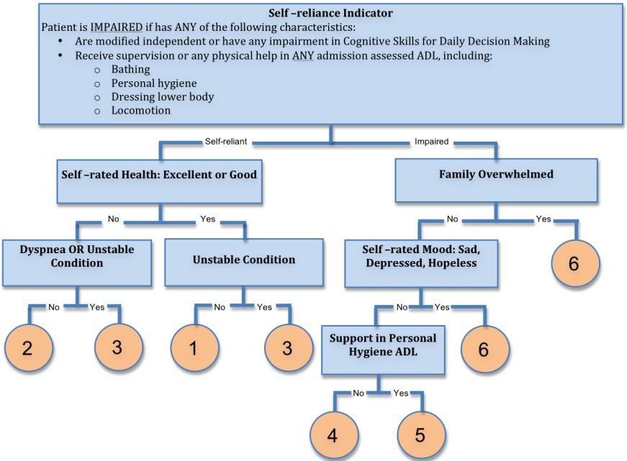

Assessor Signature: Date: