## Comprehensive Geriatric Assessment Template

Completed by: Date:

Copies to: CCAC Alzheimer Society LTC/Retirement FmDr: Specialists:

Support Person: Phone Number: Email:

## Identification Information:

Patient Name: Patient Age:

Reasons for Referral:

Patient/ Family Concerns:

## History of Presenting Problems:



## Geriatric Review of Systems:

Memory changes: ex. repeating, recalling names/appointments, language/reading/writing, insight/judgement/decision making, performing everyday tasks, personality, hallucinations/delusions/paranoia

Dementia Risk Factors: ex. Family History, Head Trauma/Contact Sports, Vascular Risks, OSA symptoms/hypoxia, known neurodegenerative illnesses

Safety Concerns: ex. wandering/getting lost, fires/floods, leaving stove/appliance on, cigarettes left burning, weapon access

Mood/Anxiety: ex. In the last 1 month how often have you felt down, depressed, or hopeless or had little interest or pleasure in doing things, or felt overwhelming worry?

Sleep: ex. snoring/apnea/unrested, daytime napping, night time routine, difficulty falling asleep vs wakening’s, use of sleep aids

Falls: frequency/week or month, proceeding events, environmental conditions, precipitating factors/symptoms, injuries/fractures, ability to get help, fear of falling, OT home assessment, osteoporosis screening?

Pain: ex. onset, location, severity, precipitating factors, investigations completed, treatments tried (NSAIDS, Tylenol, rubs, narcotics, physiotherapy, massage, chiropractor, injections, specialists)

Urinary Continence: ex. During the last 3 months have you leaked any urine? Do you use a pad or brief? Stress symptoms, urge symptoms, nocturia, hesitancy/incomplete void, functional

stress urgency nocturia hesitancy  functional

Bowels: ex. constipation, diarrhea, fecal incontinence

Nutrition: ex. weight change, appetite, chewing/swallowing/teeth, nausea/vomiting, hydration, food intake, supplements

Other Important Physical Symptoms: ex. dyspnea, chest pain, headaches, numbness/tingling, weakness

## Social History:

Alcohol/Tobacco/Drug Use: ex. current and past use?

Birth Place/Date of Immigration:

Education: Occupation:

Home: ex. levels, stairs, accessible bedroom, bathroom

Marital Status/Family: ex. names of spouse and children

Will:

Power of Attorney Finance: Personal Care:

Social Supports/Abuse:

## Functional Inquiry:

Hearing: ex. hearing aids? Do they work? Do you use them?

Vision: ex. glasses, eyedrops, last eye check, glaucoma, cataracts, macular degeneration

Gait aids: ex. cane, walker, do you use them? Were they fitted for you?

Hobbies/Leisure/clubs/religion: ex. do you do any exercise?

Home Services: ex. CCAC hours/day, private pay, what do they do for you?

Instrumental Activities of Daily Living

*Independent or assisted? note when an why changes occurred?

Driving/transportation: ex. any concerns, way finding, accidents, difficulty with turns or road position?

Medication management: ex..blister package/dosette/bottles, how many times a week miss medication dosage?

Finances: ex. any concerns, way finding, accidents, difficulty with turns or road position?

Cooking: ex. ability to use stove/appliances, ability to make family meals, spoiled food in fridge

Shopping: ex. how do you get you groceries?

Housework/yard work/ snow removal/laundry: ex. any concerns, way finding, accidents, difficulty with turns or road position?

Basic Activities of Daily Living

*Independent or assisted? note when an why changes occurred?

Transfers: ex. bed to bathroom

Bathing: ex. shower, bath, sponge bath

Dressing: ex. pick out clothes, take longer then in past

Toileting: ex. need assistance with hygiene or continence

Hygiene/oral care: ex. brush teeth, shave

Eating: ex. messy/spills, adaptive devices

Allergies/Intolerances*:*

## Medications:

Pharmacy information: ex. Name, Location, phone number

*\*Include NSAIDS, OTC’s, Vitamins, Herbals, creams, eye drops, and inhalers*

*\* for PRN’s include frequency and efficacy*

*\* for other medications include the duration of use, efficacy, and date of dosage changes*



## Past Medical/Surgical/Psychiatric History:

*\*Include hospitalizations/ diagnosis*

*\* Include name of specialists/ date last assessment*



## Physical Examination:

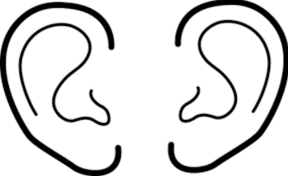Height: m Weight: kg BMI: malnourished ˂ 20 kg/m2

BP/HR lying: enter text BP/HR standing: enter text O2sat %

Visual Acuity Left: x/x Visual Acuity Right: x/x

TUG: sec. Clinical Frailty Scale: Click or tap here to enter text.

Indicate +/- cerumen

L  R

Whisper Test Left: Choose an item. Whisper Test right: Choose an item.

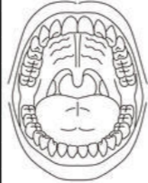Gait :Click or tap here to enter text. ex. symmetry of steps and arm swing, Stride length, stride width, posture, balance, retropulsion, tandem walking

Parkinsonism: ex. retropulsion, ability to rise from chair without arms, rest tremor, masked face, decreased blink, glabellar tap, rigidity, micrographia etc.

Cerebellar: ex. nystagmus, action tremor, dysmetria/ dysdiadochokinesia in upper or lower extremities, truncal or gait ataxia

Cranial Nerves: ex. visual fields, flattening of nasolabial fold.

PNS/CNS:

ex. pronator drift, vibration and proprioception in lower extremity

Indicate thrush, cavities, masses, ulcers

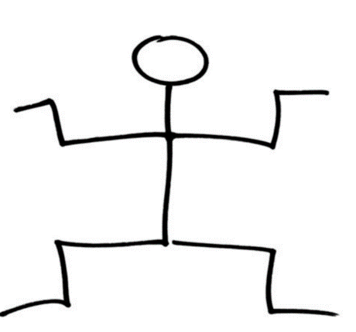MSK: Focus on joint of concern

CVS: ex, edema, PVD, murmurs, JVP.

Resp: RR, Stigmata of COPD, Auscultate lungs

Abdo: stigmata of liver disease, pain, distention, masses, palpable bladder, rectal exam if constipated.

Cognitive Testing score: Click or tap here to enter text.

Depression Screening Score: Click or tap here to enter text.

Other Screening Tool Score: Click or tap here to enter text.

Reflexes

* 0 = no response
* 1+ = a slight but definitely present response
* 2+ = a brisk response; normal.
* 3+ = a very brisk response
* 4+ = clonus

Strength

0/5: no contraction

1/5: muscle flicker, but no movement

2/5: movement possible, but not against gravity

3/5: movement possible against gravity, but not against resistance by the examiner

4/5: movement possible against some resistance by the examiner

5/5: normal strength

Laboratory Tests and Investigations:

Problem List/Suggestions: